Question:

Design a simple flowchart and pseudocode to represent the steps you follow to complete your daily assignments.

Problem Definition:

Completing assignments on time can be challenging without a proper plan. This algorithm helps organize the process — from listing assignments, working on them one by one, to reviewing and submitting them.

Flowchart:

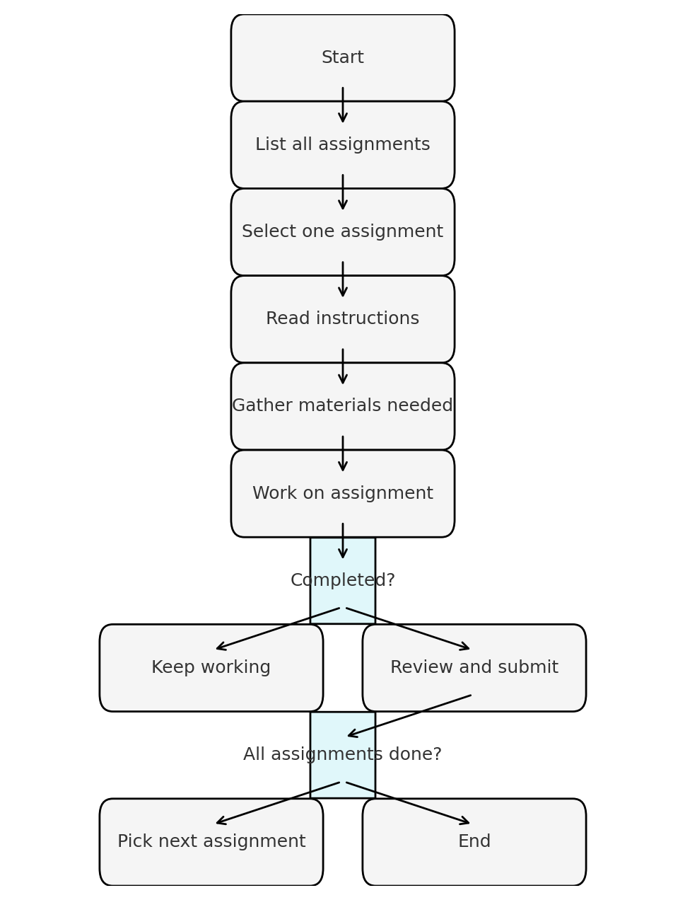

Pseudocode:

BEGIN  
 CREATE a list of all assignments  
 FOR each assignment in the list DO  
 DISPLAY assignment name  
 READ and understand instructions  
 GATHER necessary materials  
 WHILE assignment not completed DO  
 WORK on assignment  
 END WHILE  
 REVIEW the work  
 SUBMIT the assignment  
 END FOR  
 DISPLAY "All assignments completed successfully!"  
END

Expected Output:

All assignments are completed, reviewed, and submitted before the deadline.